Department of Computer Science and Engineering
Lab Report
Lab Report No | : | 02
Lab Report Name | : | Magic Square, Queue and Stack Implementation
Course Title | : | Computer Algorithm and Complexity Sessional
Course Code | : | CSE 222
Name | : | Fahim Faisal Pathan
ID | : | 1119033
Level | : | 2 | Term | : | 2 | Section | : | A | Group | : | G2
Date of Submission | : | 06/05/2026 | Semester | : | Spring | Year | : | 2026

Marking Rubric
Problem Understanding & Report Clarity (3) | Implementation (4) | Results, Analysis & Presentation (3) | Total(10)

Key Learning:
- The program creates a Magic Square using a 2D array for odd numbers only.
- It checks whether the entered number is odd using the modulus operator %.
- All matrix elements are initialized with 0 before inserting values.
- The first number starts at the first row and middle column position.
- The algorithm moves one step up and one step right for each new number.
- Nested loops are used for matrix initialization, number placement, and printing output.
- Queue Follows FIFO that means First In First Out.
- Uses modulus operation for reusing empty space.
- Uses of insertion, deleting.
- Uses of front and rear.
- To understand the concept of a stack data structure.
- To implement a stack using arrays and linked lists.
- To perform basic stack operations: push, pop, peek, and check for underflow/overflow.

Source Code & Output
Code Input 1:

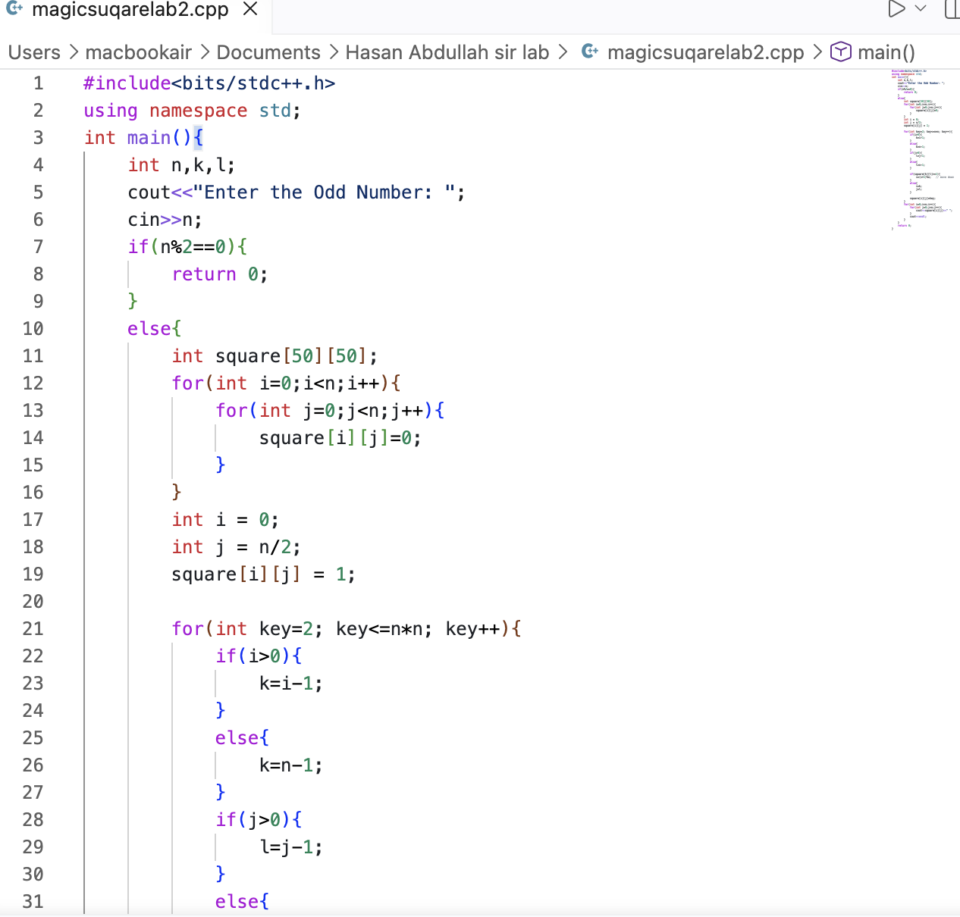

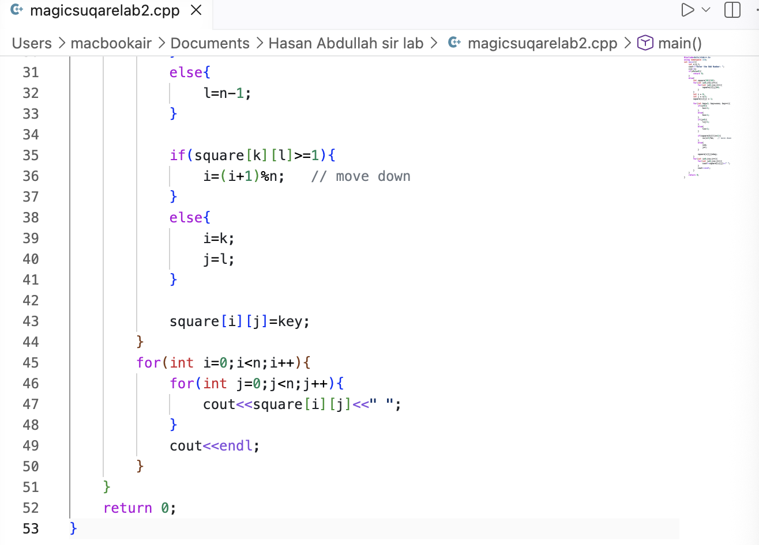

Code Output:
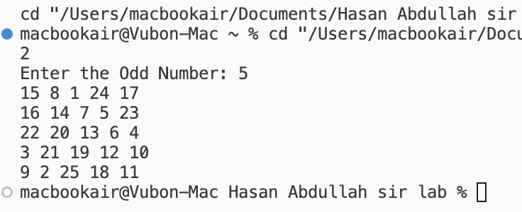

Code Input 2(Queue) :
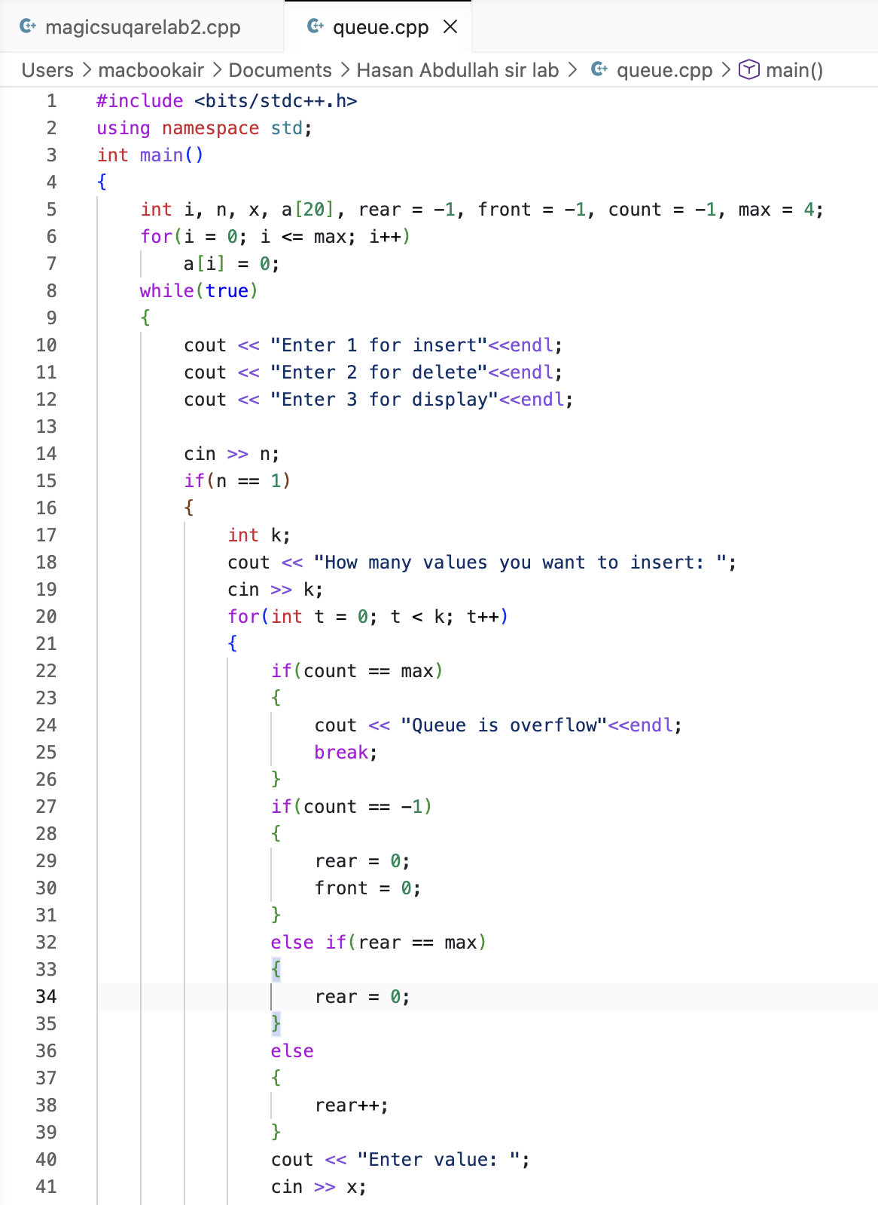

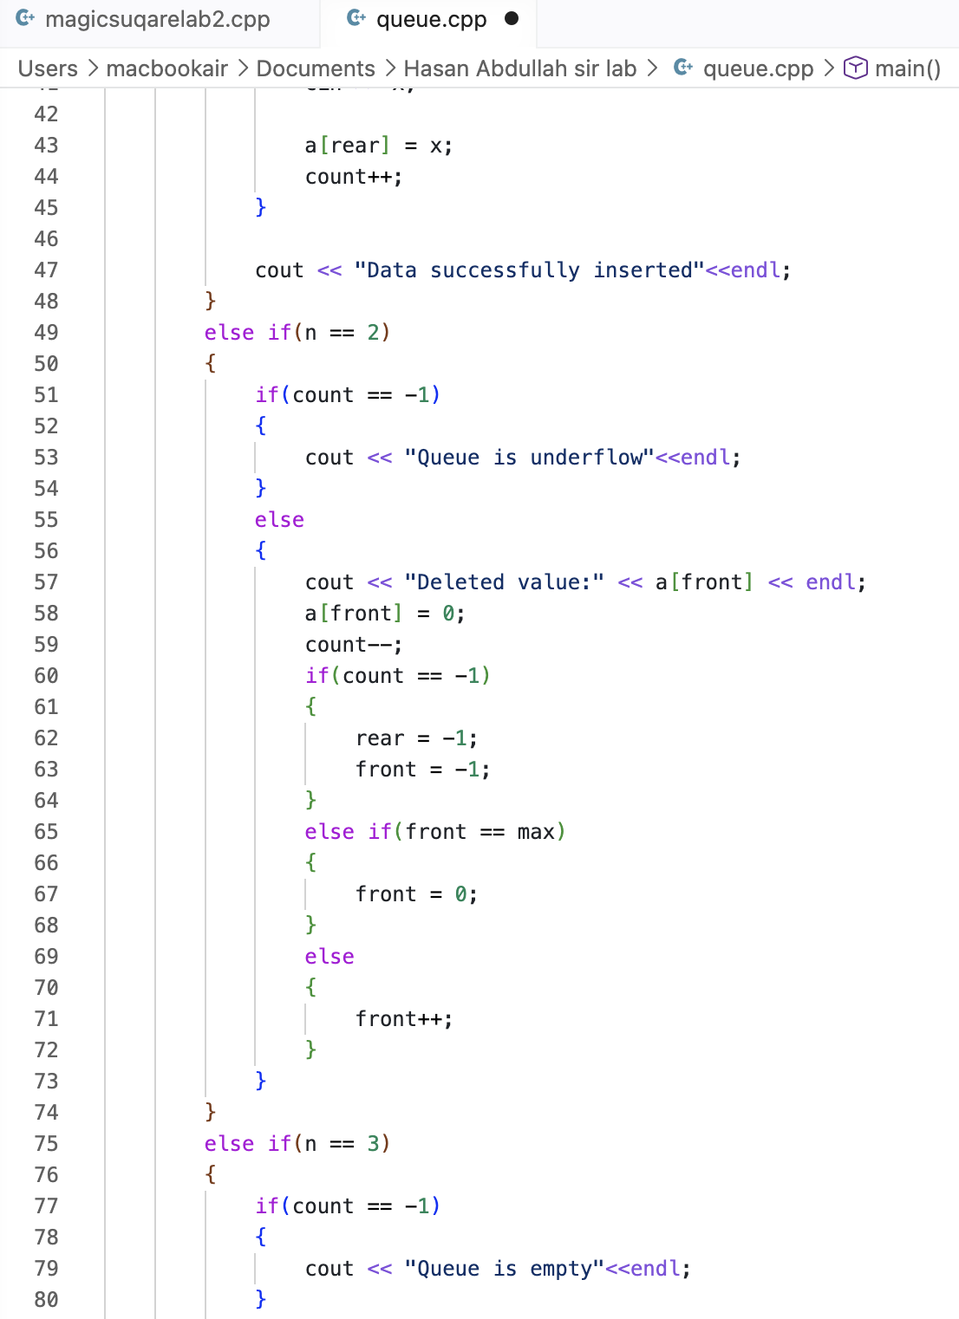

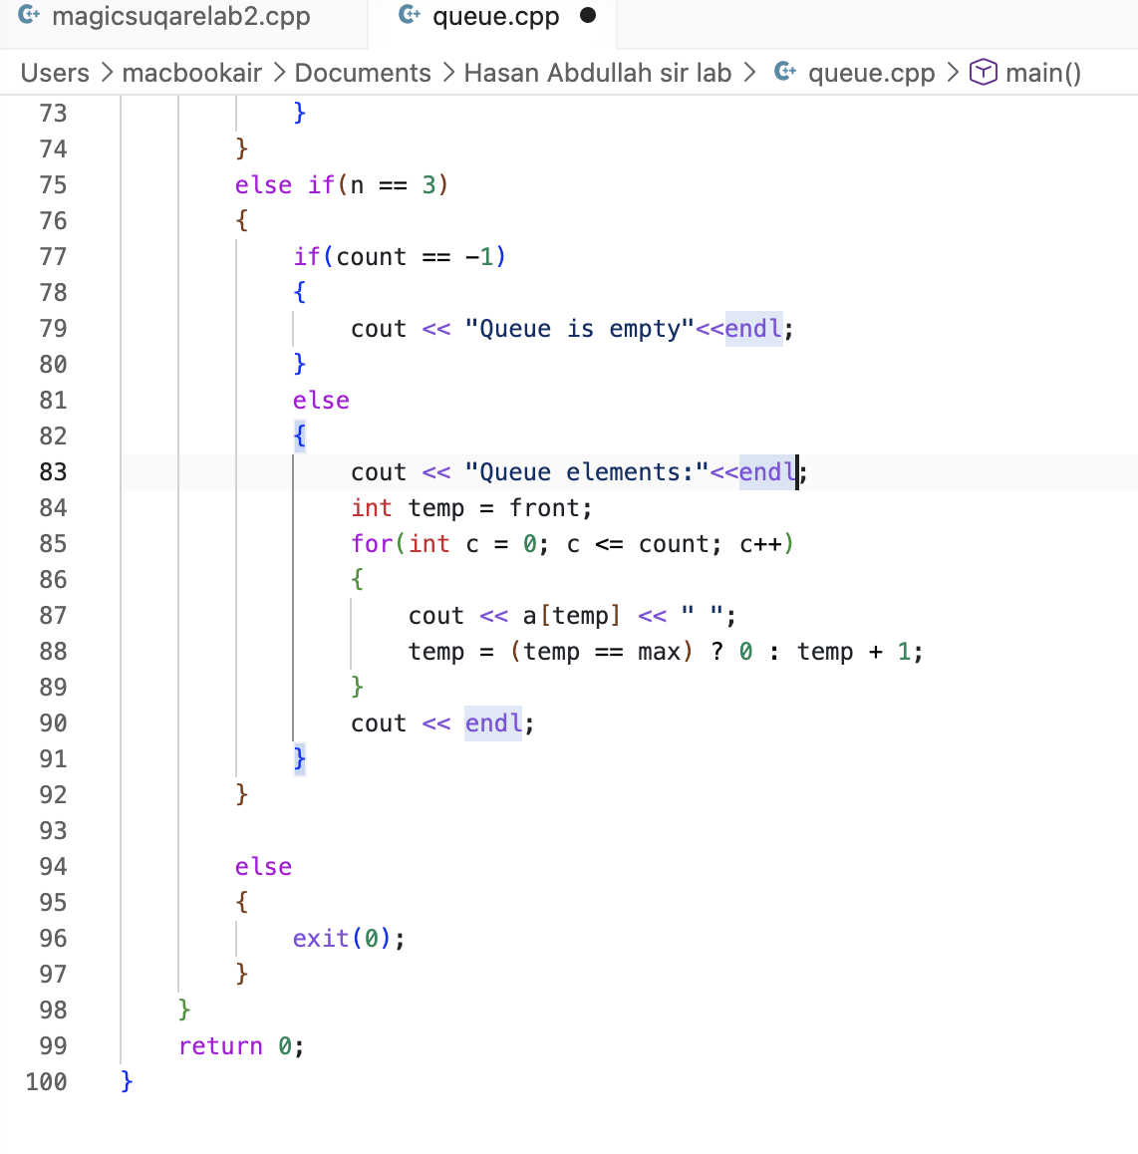
Code Output:
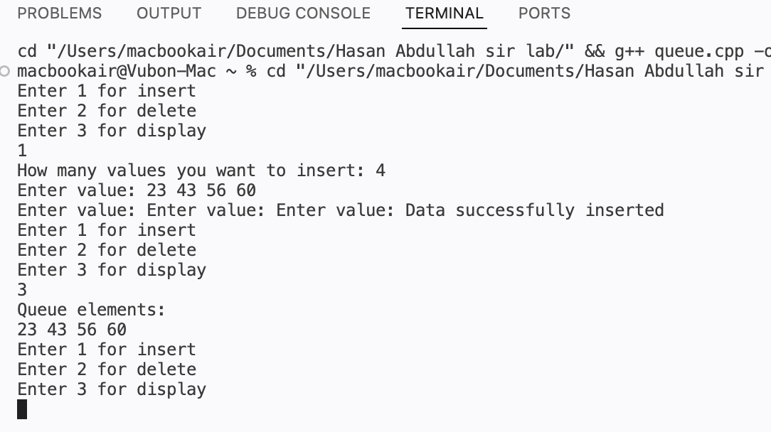
Code Input 3(Stack):
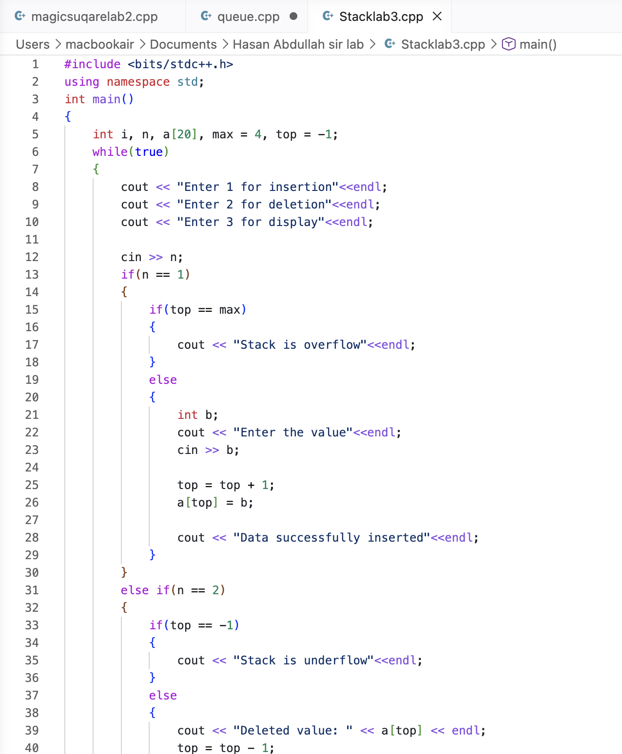

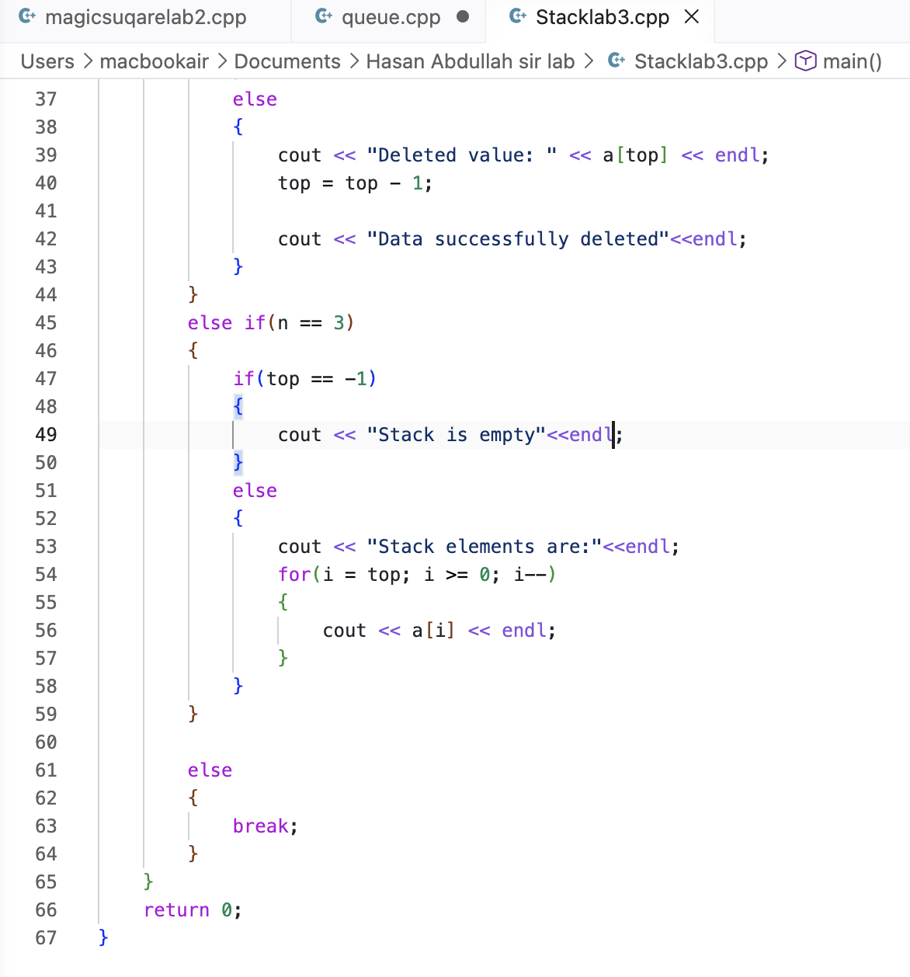

Code Output:
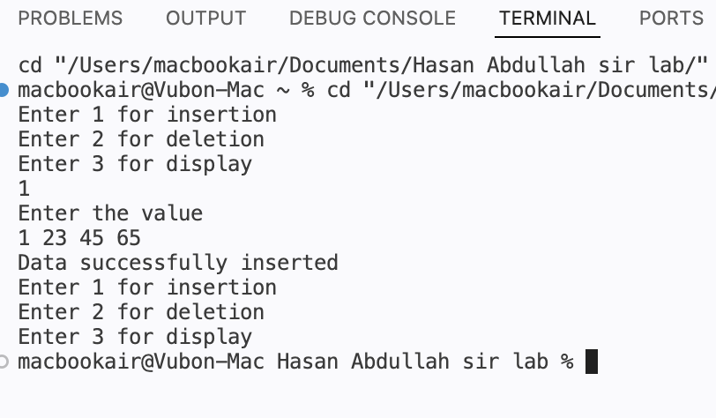

Conclusion:
The Magic Square demonstrates how a mathematical pattern can be generated using a step-by-step algorithm with proper movement rules, boundary handling, and logical conditions. It strengthens understanding of matrix operations and problem-solving techniques.
On the other hand, Stack and Queue are fundamental data structures used for storing and managing data efficiently. A Stack follows the LIFO (Last In First Out) principle, while a Queue follows the FIFO (First In First Out) principle. The Circular Queue further improves memory utilization by reusing empty spaces through circular indexing.

